**Training Manual for Data Managers on Best Practices in Meteorological Observation Procedures**

**TABLE OF CONTENTS**

1. INTRODUCTION 2

2. CLIMSOFT INSTALLATION 3

2.1. USER INTERFACE 3

2.2. BACK-END 3

2. CONFIGURE TO MAIN SERVER 4

3. CLIMSOFT OVERVIEW 4

3.1 User administration 4

3.2 Metadata 5

3.3 Data entry 5

3.4 Quality Control Check 7

3.5 Data transfer 8

3.6 Climate Products 8

4 DATA BACK UP 8

4.1 Data Backup 8

4.2 Data Restore 9

5 EXTERNAL TOOL FOR DATA QUALITY CONTROL 10

6 EXTERNAL TOOL FOR DATA ENTRY 13

7 CONCLUSION 22

# **INTRODUCTION**

Climsoft is a comprehensive software system designed to securely store, manage, and analyze climatic data. Developed in Microsoft Visual Basic .NET, with MariaDB as its default database engine, Climsoft provides a flexible platform that supports multiple meteorological stations and offers tools for both data management and analysis.

The system includes key functionalities such as data entry through a secure key-entry component, importing data from various sources (e.g., Automatic Weather Stations, CLICOM ASCII, NOAA GTS, and text files), and exporting datasets into formats compatible with widely used climate applications such as RCLIMDEX, CPT, GEOCLIM, INSTAT, ENACTS, and CDT. Additional features include the management of scanned paper records for data rescue, comprehensive quality control checks, generation of climate products (summaries, reports, and diagrams), and robust system administration facilities for access control and customization.

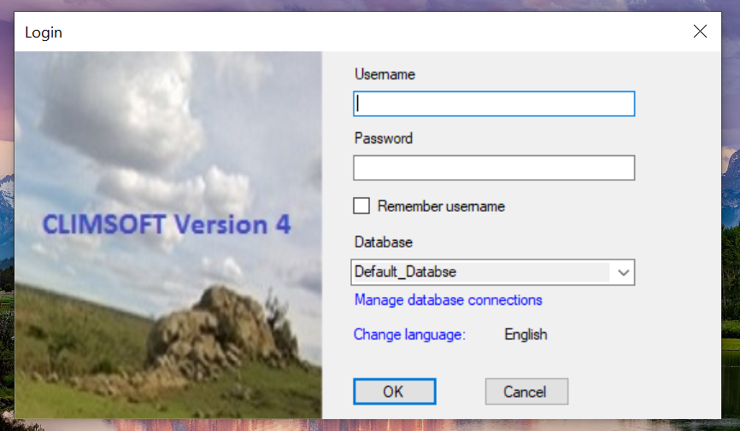

Figure 1:Climsoft login page

In addition to Climsoft’s built-in tools, several external applications complement its functionality:

* **Data Quality Control Tool**: A Microsoft Excel Add-in customized with VBA scripts to align with Climsoft’s data entry forms (form_hourly and form_daily1). This tool automates quality control checks and supports data inventory management.
* **Night-hour Calculation and Data Entry Tool**: An Excel Add-in based on psychrometric equations (developed with VBA) for calculating dew point, vapor pressure, and wet-bulb temperature. Additionally, an external Python-based application is used to streamline the process of uploading data into Climsoft.

Together, Climsoft and its external tools provide a reliable framework for managing the entire cycle of climate data from entry and validation to storage, quality control, and product generation.

# **CLIMSOFT INSTALLATION**

Climsoft is the free open source Climate database management available with full set up and upgrade at <https://climsoft.org/>.

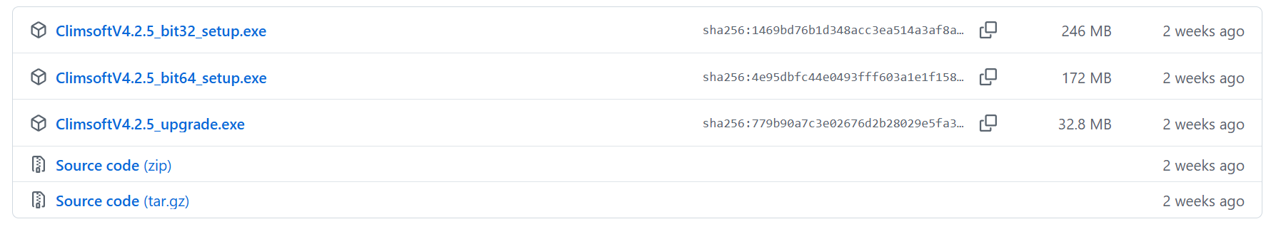

Figure 2:Climsoft setup

## **2.1. USER INTERFACE**

Depend on the bit of computer a full set up of climsoft is downloaded( [ClimsoftV4.2.5_bit32_setup.exe](https://github.com/climsoft/Climsoft/releases/download/V4.2.5/ClimsoftV4.2.5_bit32_setup.exe) or [ClimsoftV4.2.5_bit64_setup.exe](https://github.com/climsoft/Climsoft/releases/download/V4.2.5/ClimsoftV4.2.5_bit32_setup.exe)) after downloading the following steps are followed during installations.

1. Double click on setup and follow installation steps
2. Tick the installation of MariDB
3. During installation of MariaDB put the root password and confirm it.
4. Change the Port from 3306 to 3308.
5. Proceed to finish

## **2.2. BACK-END**

1. Install climsoft in MariaDB
2. Open MySQL client and put the **root password**
3. Type source followed by path “**Source C:\Program Files (x86)\Climsoftv4\Dbase\mariadb_climsoft_db_v4_all.sql**”
4. Now login in Climsoft with

Username:**root**

Password: **Created passoword** on **ii**

1. Now login into HeidiSQL with the same credentials and see the installed software of **mariadb_climsoft_db_v4.**



Figure 3:HeidSQL icon

This is mainly made by the MariaDb where all data are stored in designed table such as

* form_hourly
* form_daily1
* form_daily2
* etc

# **CONFIGURE TO MAIN SERVER**

1. Open Climsoft and click to Manage database connections then the server address.

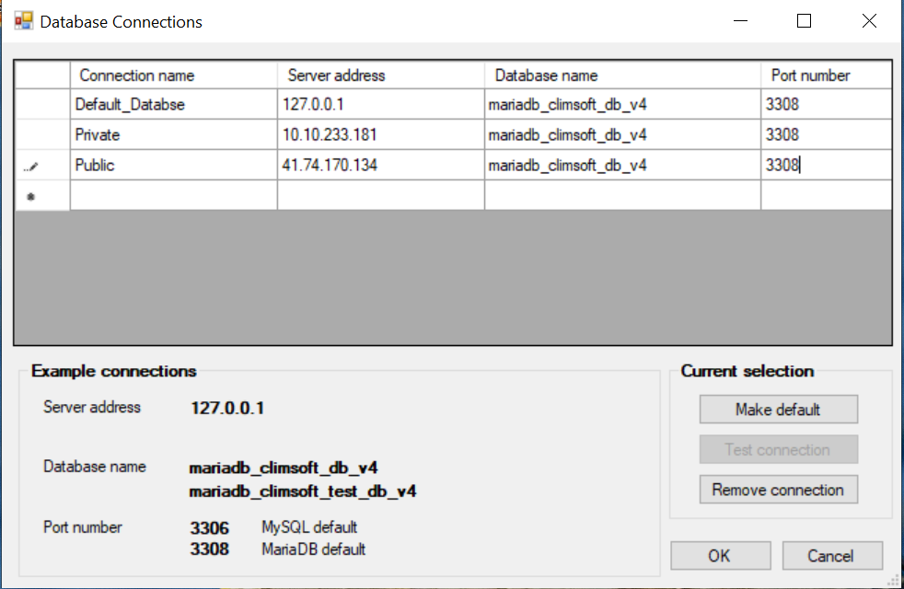

Figure 4:Climosft interface to configure IP address of servers

# **CLIMSOFT OVERVIEW**

## **3.1 User administration**

Create new user, update password and user role.

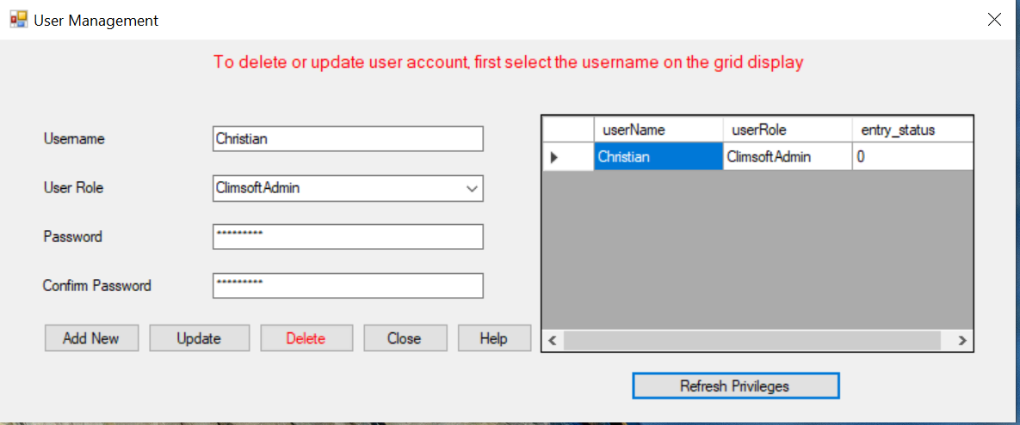

Figure 5:Climsoft's users management

## **Metadata**

To view and update of station, element, instrument,

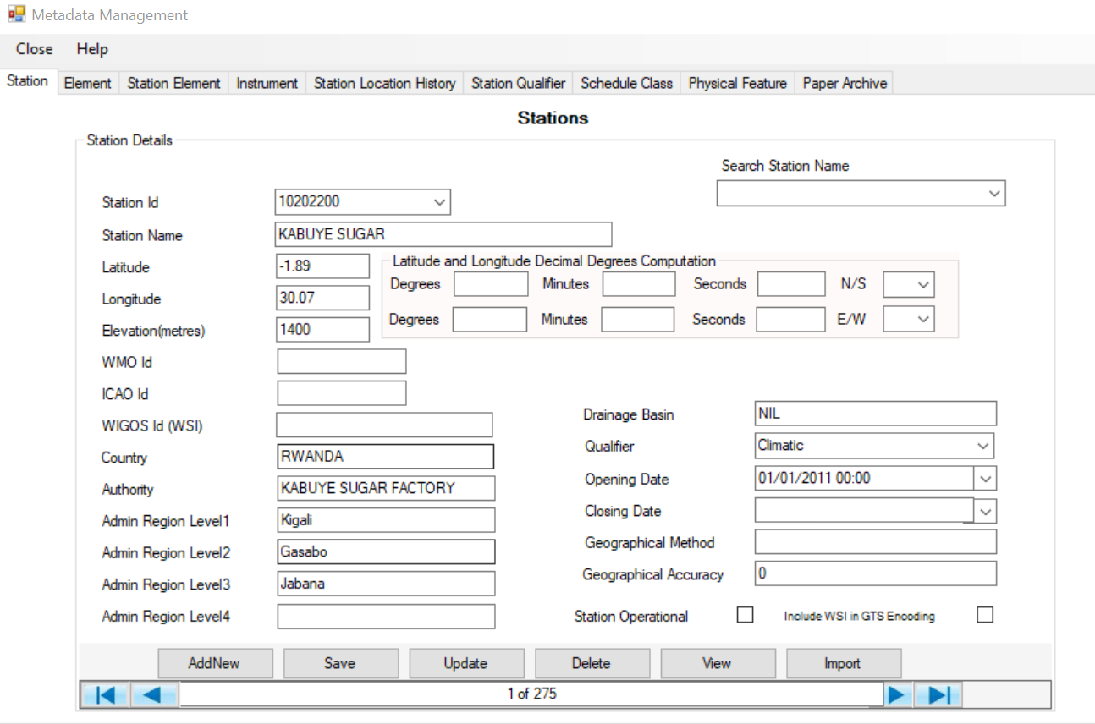

Figure 6:Metadata's page

## **Data entry**

Data are entered through two form

**form_hourly:**to record hourly data

|  |  |  |  |  |  |
| --- | --- | --- | --- | --- | --- |
| # | **Element Code** | **Abbreviation** | **ElementName** | **Description** | **Units** |
| 1 | 101 | TEMPDB | Temp Dry Bulb | Temperature dry bulb | Degrees C |
| 2 | 102 | TEMPWB | Temp Wet Bulb | Temperature wet bulb | Degrees C |
| 3 | 103 | TEMPDP | Temp Dew Point | Temperature dew point | Degrees C |
| 4 | 104 | PRECIP | Precip Hourly Total | Precipitation total hourly | Millimeters |
| 5 | 105 | RELHUM | Relative Humidty 06Z | Relative humidity at 06Z | Percent |
| 6 | 106 | PRESST | Pressure Station | Pressure station | Hectopascals |
| 7 | 110 | VISBY | Visibility Hor | Visibility horizontal | Coded |
| 8 | 112 | WNDDIR | Wind Direction | Wind direction | Degrees C |
| 9 | 115 | CLDOPC | Cloud Opacty tot | Cloud opacity total | Octas |
| 10 | 166 | VAPPSR | Vapor Pressure | Vapor Pressure | Hectopascals |
| 11 | 196 | WDSPDMS | Wind Speed m/s | Wind Speed in Meter per Second | m/s |
| 12 | 183 | THMGRF | Temp THMGRF Hly | Temperature of Thermograph | Degrees C |
| 13 | 184 | RHHYGR | RH Hygrograph Hly | Relative humidity hygrograph | Percent |
| 14 | 153 | FOG | Weather-Fog | Weather fog | Coded |
| 15 | 141 | THUNDR | Weather-Thunder | Weather thunderstorms | Coded |

**form_daily1:to records daily data**

|  |  |  |  |  |  |
| --- | --- | --- | --- | --- | --- |
| # | **Element Code** | **Abbreviation** | **ElementName** | **Description** | **Units** |
| 1 | 2 | TMPMAX | Temp Daily Max | Temperature daily maximum | Degrees C |
| 2 | 3 | TMPMIN | Temp Daily Min | Temperature daily minimum | Degrees C |
| 3 | 5 | PRECIP | Precip Daily | Precipitation daily total | milmiters |
| 4 | 15 | RHMAX | RH Daily Max | Relative humidity daily maximum | % |
| 5 | 16 | RHMIN | RH Daily Min | Relative humidity daily minimum | % |
| 6 | 18 | EVAPPN1 | Evap Pan1 Daily | Evaporation pan1 daily total | Millimeters |
| 7 | 84 | SUNSHN | Sunshine Daily Tot | Sunshine Daily total amount | Hours |
| 8 | 85 | GRSMIN | Grasss Min Temp 06Z | Grass Minimum Temperature at 06Z | Degrees C |
| 9 | 92 | SUNSHNPM | Insolation Afternoon | Insolation Afternoon | Hours |
| 10 | 93 | SUNSHNAM | Insolation Morning | Insolation Morning | Hours |
| 11 | 477 | EVAPPICHE | Evap Piche Daily | Evaporation Piche daily | Millimetres |
| 12 | 516 | T1006 | Soil Temperature; 10cm 06H | Temp; Soil at 10 cm 06H | Degres C |
| 13 | 517 | T1012 | Soil Temperature; 10cm 12H | Temp; Soil at 10 cm 12H | Degres C |
| 14 | 518 | T1018 | Soil temp 10cm 18h | Soil Temperature at 10cm 18h | Deg Celsius |
| 15 | 570 | T2006 | Soil Temperature; 20cm 06H | Temp; Soil at 20 cm 06H | Degres C |
| 16 | 571 | T2012 | Soil Temperature; 20cm 12H | Temp; Soil at 20 cm 12H | Degres C |
| 17 | 572 | T2018 | Soil Temperature; 20cm 18H | Temp; Soil at 20 cm 18H | Degres C |
| 18 | 573 | EP0618 | EVAPO.PICHE.0618 | EVAPO.PICHE.0618 | mm |
| 19 | 574 | EP1806 | EVAPO.PICHE.1806 | EVAPO.PICHE.1806 | mm |
| 20 | 575 | EB0618 | EVAPO.BAC. 0618 | EVAPO.BAC. 0618 | mm |
| 21 | 576 | EB1806 | EVAPO.BAC. 1806 | EVAPO.BAC. 1806 | mm |
| 22 | 75 | SOIL50 | Temp Soil50 Dly | Temperature soil daily at 50 cm | Degrees C |
| 23 | 76 | SOIL1M | Temp Soil100 Dly | Temperature soil daily at 100 cm | Degrees C |

## **Quality Control Check**

Quality control (QC) in data management ensures that the collected data is reliable, valid, and consistent. The main QC checks include:

* **Absolute limits Checks**

This check verifies whether each parameter (e.g., temperature, rainfall, humidity, wind speed) falls within a **plausible physical range**.

**Example**: Air temperature cannot be below **–90°C** or above **+60°C**. Rainfall cannot be negative. If a value falls outside these absolute limits, it is flagged as an error or suspect.

* **Inter_element comparison checks**

This check compares **related parameters** to ensure they are logically consistent.

Example: Minimum temperature should not be higher than maximum temperature. Relative humidity should not exceed 100%. Sunshine duration cannot exceed the total daylight hours of a day.

* **Consecutive days consistency check**s

This check ensures that values reported on **successive days** are consistent and do not show unrealistic jumps.

Example: If today’s maximum temperature is 30°C, tomorrow’s cannot suddenly drop to 5°C without a valid reason. Similarly, cumulative values like rainfall should not decrease from one day to the next.

* **Consecutive hours consistency checks**

Similar to the daily check, but applied at the **hourly level**. It verifies that hourly data changes gradually and realistically.

Example: Air temperature should not rise by 15°C in one hour under normal conditions. Pressure should not drop suddenly unless a strong weather system is passing.

## **3.5 Data transfer**

* This involve the uploading the uploading the data from external file into Climsoft (observation final)

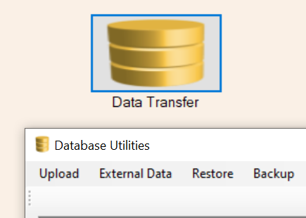

Figure 7:Data Transfer

* Archiving checked data in the final stage (observation initial to observation final) is conducted in data transfer.

## **Climate Products**

To access the archived data a user uses the icon of the Climate Products to extract data and conducting data inventory.

# **DATA BACK UP**

## **Data Backup**

**User interface method**

* Open Climsoft
* Go to Data transfer
* Go Backup
* Select folder and rename the file
* Backup

**Back end method**

* **Open HeidSQL**
* **Right click on data base name**
* **Select Export database as SQL**
* **Select folder and rename the file**
* **Export**

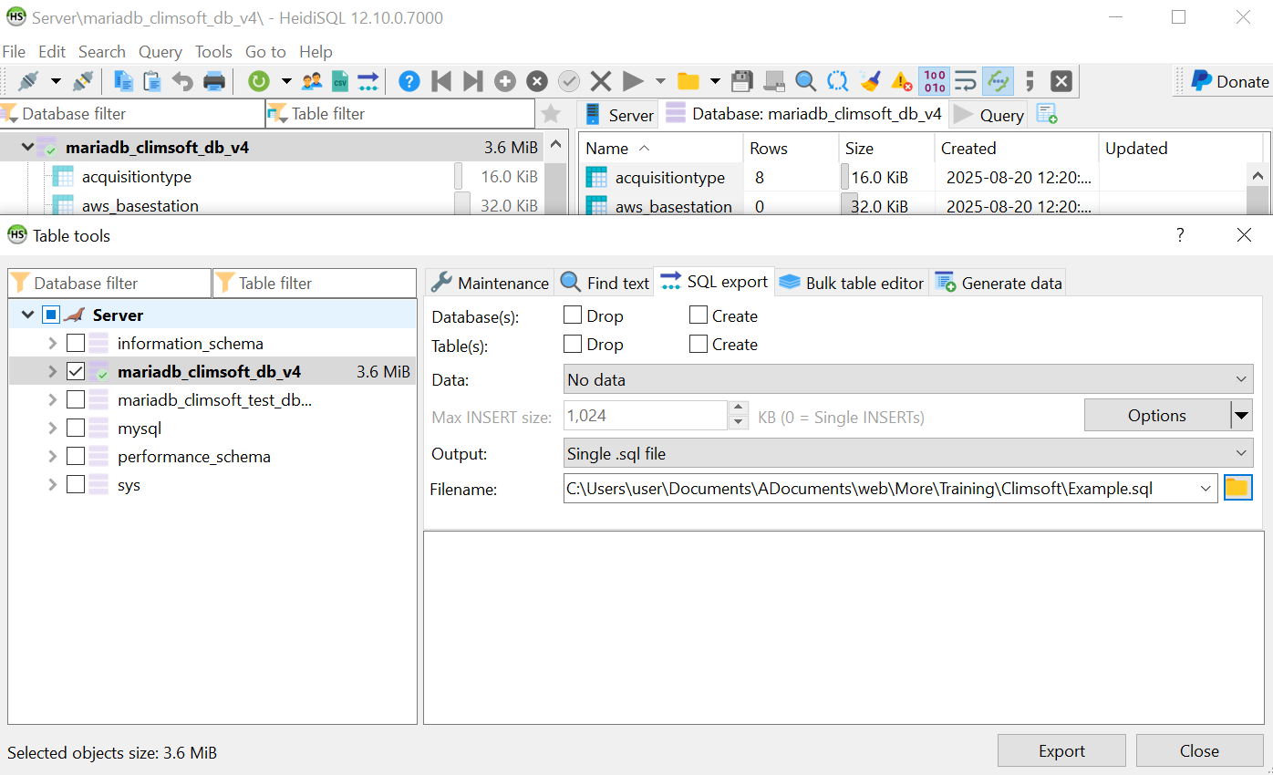

Figure 8:Data backup with Heidsql

## **Data Restore**

**User interface method**

* Open Climsoft
* Go to Data transfer
* Go Backup
* Select a file
* Restore

**Back end method**

* Open MySQL Client
* Enter password
* Enter Source path\filename.sql
* Click Enter

# **EXTERNAL TOOL FOR DATA QUALITY CONTROL**

The tool is designed to work alongside Climsoft to carry out data quality control checks and manage data inventory in the data entry forms (**form_hourly** and **form_daily1**). It is installed as a customized **Microsoft Excel Add-in**, tailored to the structure of these forms, and operates through a **Visual Basic for Applications (VBA) script** that automates the required quality control and inventory tasks.

Step to use it.

* **Get the file data of form_daily1 and form_hourly**
* Open Climsoft
* Go to Data entry
* Select form
* Click to View
* Click to Export
* Select destination folder
* Save
* Close
* Inventory and QC of daily data
* Open the exported form_daily1
* Click on Tab name **QC**

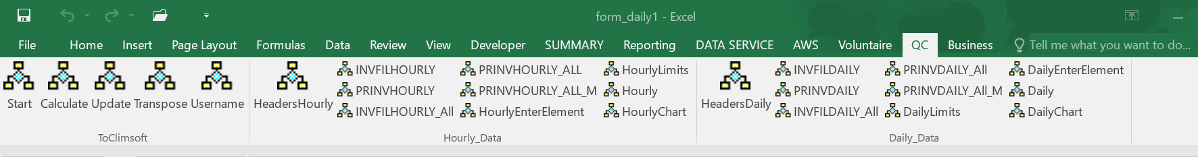

Figure 9:QC icon in Microsoft Excel

* Look for group of **Daily_data**
* Click **headerdaily** to insert the headings
* Click **INVFILDAILY** to select the daily data of the specific month
* Enter your station (new sheet in the name of station will be created) and click OK.

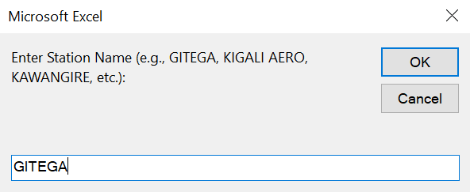

Figure 10: Prompt requesting the user to input the Station name

* Enter a year and click ok

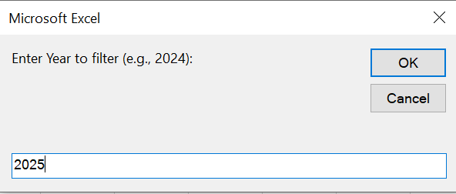

Figure 11:Prompt requesting the user to input the year

* Enter a month and click ok

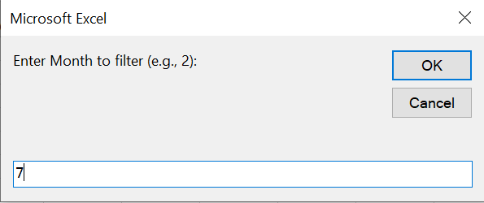

Figure 12:Prompt requesting the user to input the Month

Once you done the daily data of the entered year and month will be copied in automated created sheet appear in your station name.

* Click the **PRINVDAILY** for conducting daily data inventory

Once you click it will generate the Microsoft word document which named as **Missing data_Daily_STATION_DAYDATE.doc**.and will be automatically save in the provided path.

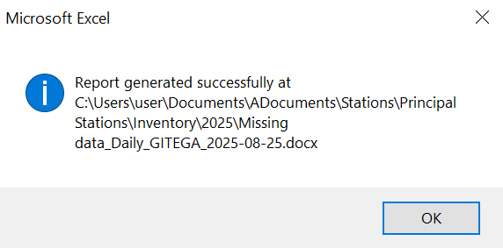

Figure 13:Confirmation message: Report has been saved successfully

The Generated report is made of missing element listed in table of 6 columns

* **Station Name**: your station
* **Year**: Year of the data you are checking
* **Month**: Year of the data you are checking
* **Day**: In case there is missing data at day, the day will be listed.
* **Missing Element Parameters**: missing parameters (the description of parameters are listed in Element codes): it lists all missing parameters and highlight in red the missing elements due lack of instruments.
* **Verified**: By default, all values are **NO**, and will be updated after verifications.

Report have a section of summary

Total Expected Data Points: Number of data points that must be taken based on available instruments.

Total Missing Data Points: Number of missing data from the available instruments

Total Available Data Points: Number of recorded data

Percentage of Available Data: percentage of available data regarding to Total Expected Data Points.

* Click the **PRINVDAILY** for conducting enter_elements comparison checks.

The Generated report is made of missing element listed in table of 7columns

* **Station Name**: your station
* **Year**: Year of the data you are checking
* **Month**: Year of the data you are checking
* **Day**: the day error happened.
* **Elements IDs**: element codes of errors data.
* **Elements Values**: the recorded values
* **Error type**: description of error.
* **Verified**: By default, all values are **NO**, and will be updated after verifications.
* Click the **PRINVDAILY** for conducting Absolute limits and Consecutive days consistency checks.

The Generated report is made of missing element listed in table of 9 columns

* **Station Name**: your station
* **Year**: Year of the data you are checking
* **Month**: Year of the data you are checking
* **Day**: the day error happened.
* **Elements IDs**: element codes of errors data.
* **Elements Values**: the recorded values.
* **Limit Error:** description of absolute limits checks.
* **Consistency Error:** Consecutive days consistency checks.
* **Verified**: By default, all values are **NO**, and will be updated after verifications.

Both report will be saved in specified destination folder with in the name of ther type of Qc.

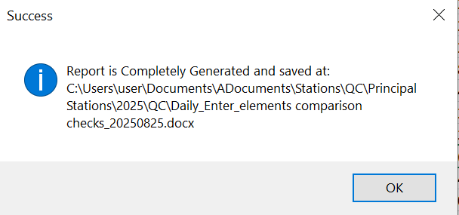

Figure 14:Confirmation message: Report has been saved successfully

The same procedures are applied to hourly data.

# **EXTERNAL TOOL FOR DATA ENTRY**

It has been noted that human errors frequently occur during data entry, particularly with mismatched element codes on the third page of the observation notebook (which includes dry-bulb, wet-bulb, relative humidity, vapor pressure, dew point, thermography, and hygrograph readings). Similar errors are also observed when calculating night-time data. To eliminate these issues, it is crucial to implement a system that automatically calculates the night data and uploads it directly into Climsoft and avoiding the manual entry.

1. **Current method of Calculating Night-Data.**

During nighttime hours, when observers are not working, data on Relative Humidity, Dry-air Temperature, Partial Vapor Pressure, Wet-bulb temperature, and Dew-point temperature are missing.

To determine those methods the following steps are employed;

* + - 1. The relative humidity and dry bulb temperature are acquired through Microsoft Excel by utilizing a regression line derived from comparing the humidity and temperature observed on digital and analog instruments. This regression line is then utilized to determine the relative humidity and temperature of the digital instrument from the night data of the hygrograph and thermograph.
      2. Using an online calculator known as the psychometric calculator, accessible at <https://www.kwangu.com/work/psychrometric.htm>, Partial vapor pressure, Wet-bulb temperature, and Dew-point temperature are determined by inputting the relative humidity and Dry-bulb temperature .

**Disadvantages of this method**

1. The obtained results are slightly smaller compared to the expected results, likely due to rounding errors in the decimal values.
2. Errors stemming from typing mistakes can also contribute to discrepancies in the obtained results.
3. The process is time-consuming because the psychrometric calculator accepts only one input.
4. Obtained are entered manually in Climsoft which arise another errors.
5. **Proposed Method**

The proposed approach utilizes psychrometric equations implemented through a Microsoft Excel add-in, developed using Visual Basic for Applications (VBA).

* **Saturated vapour pressure, W.**

Saturated vapor pressure is directly proportional to the Dry air temperature, and their relation is given by the Equation 1.

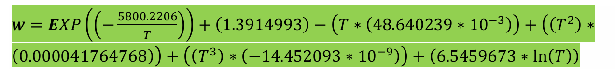

Equation 1:Saturated Vapour pressure

**w**: Saturated vapor pressure,

**T**: air temperature (dry-bulb temperature) in kelvin

* **Partial Vapour Pressure, e.**

The partial vapor pressure is influenced by both saturated vapor pressure and humidity.

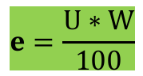

Equation 2:Partial Vapour pressure

U: Relative humidity

**w**: Saturated vapor pressure,

* **Dewpoint temperature, Td.**

𝑻𝒅 = 1.1689 ∗ (ln(𝑒))2 − 1.8726 ∗ ln(𝑒) − 35.777

Equation 3:Dew point temperature

e: Partial Vapor Pressure.

* **Wet-bulb temperature, Tw.**

𝑇𝑤 = (𝑇 ∗ 𝑎𝑟𝑐𝑡𝑎𝑛(0.151977 ∗ (𝑈 + 8.313659)0.5)) + arctan(𝑇 + 𝑈) − arctan(𝑈 − 1.676331) + ((0.00391838 ∗ (𝑈)1.5) ∗ (arctan(0.023101 ∗ 𝑈))) − 4.586035

Equation 4:Wet bulb temperature

T: dry-bulb temperature in degree Celsius

1. **User’s Guide of Proposed Methodology**

**Case Study: GITEGA STATION**

* **Station Id:**10101100
* **Data entry:** hourly data of previous day are entered on the next consecutive day.

1. **Open new excel Workbook**

* Clicking on new tab available in Microsoft excel named **“QC”**

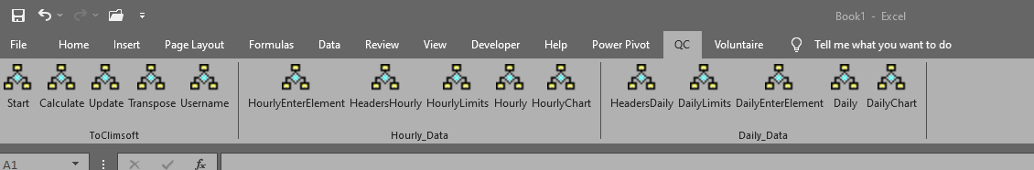

Figure 15:QC Tab

* Under **QC** tab look for “**ToClimsoft**” group

1. Click “**Start**”

By click on Start, ActiveSheet(sheet1) will be automatically filled of station Id,Element Id, Year (of previous day), month (of previous day), day (previous day), parameter name and hours.

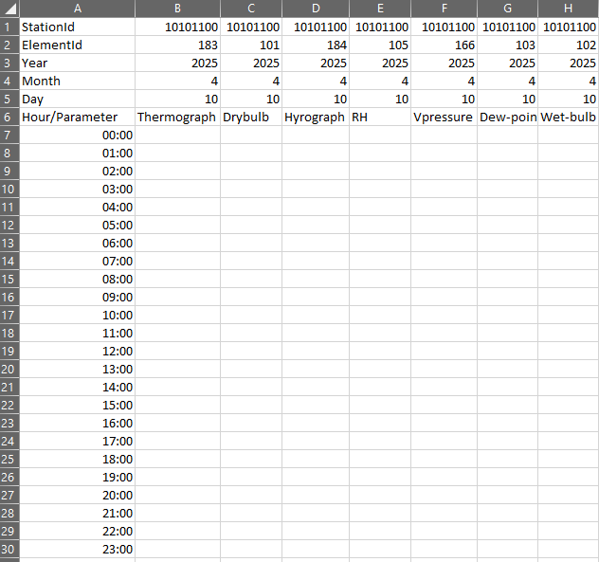

Figure 16:By clicking on Start

Figure 1 shows the display when start is clicked, it displays a year of 2025, month of 4 and a day of 10 as this report done on 11-April-2025.

1. Enter the available and finds regulation line between Thermography and Dry-bulb, Relative Humidity and hygrography in the same way of current method.

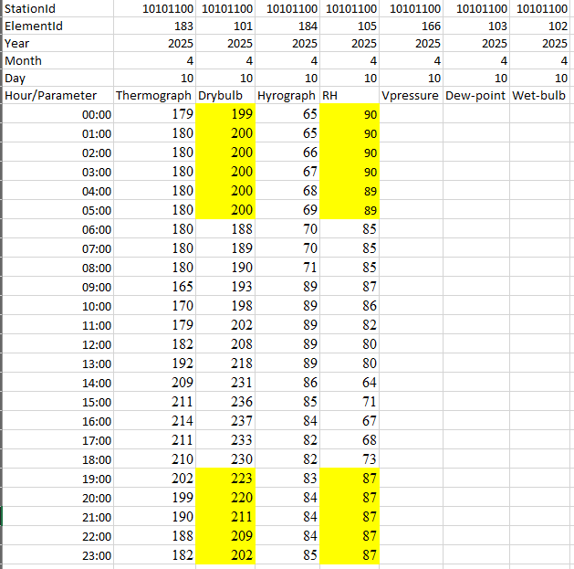

Figure 17:Input data

1. Click “**Calculate**”

By Clicking on the Calculate that mean a user is going to calculate the Vapor pressure, dew-point temperature and wet-bulb temperature of night hours.

* A user is asked to put the range of hours to exclude (usually day hours)

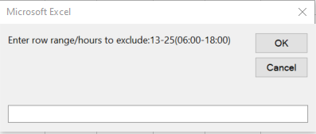

Figure 18:Enter the range of Available data

* Click “**ok**”
* After clicking ok the night data are calculated.

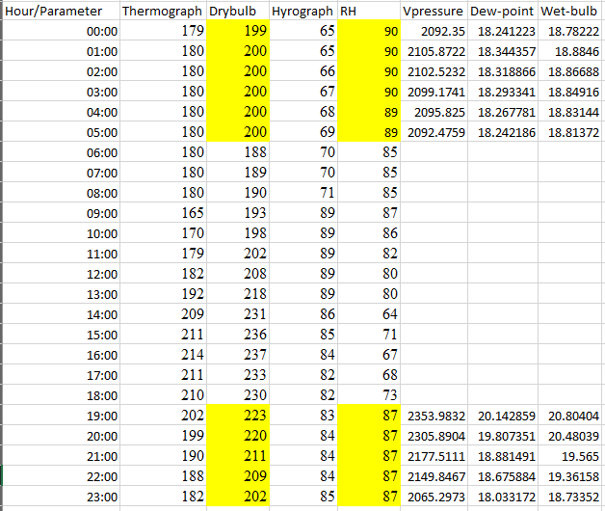

Figure 19:Calculated Night hours data.

1. Click “**Update**”

Partial vapor pressure is entered in hPa, while dew point and wet-bulb temperatures are entered as three digits. To standardize the values, clicking the "**Update**" button will divide the vapor pressure by 10, and multiply both the wet-bulb and dry-bulb temperatures by 10 accordingly.

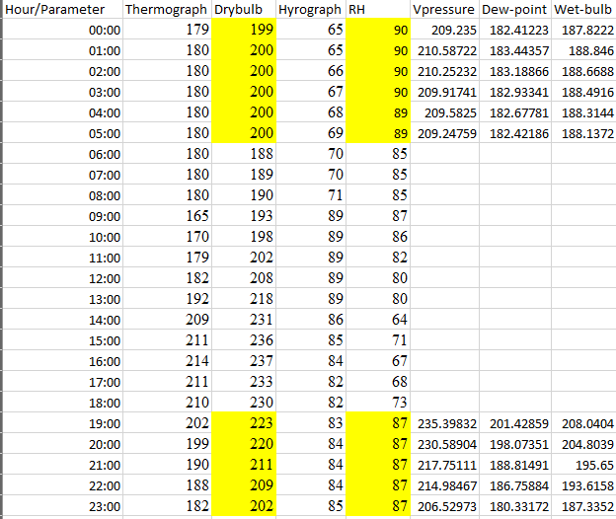

Figure 20:Update the data

1. Click “**Transpose**”

By Clicking on transpose, the data are arranged in format of “**form_hourly**” so that are able to be uploaded in Climsoft.



Figure 21:data in form_hourly format.

1. Click “**Username**”

* To add a signature of username and data entry time is done by clicking username, a user asked to put his/her name of climsoft.

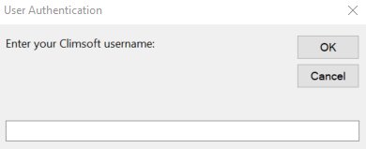

Figure 22:User Authentication

* Click “**ok**”

By clicking ok user name and time are inserted in each cell of row that has data.

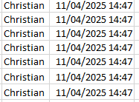

1. **Data import in Database**

**Steps for data entry**

1. Save file in any name with **Excel Workbook** file type**.**
2. Open (Double Click) an app named **Local_V1.**1 which is available on desktop.

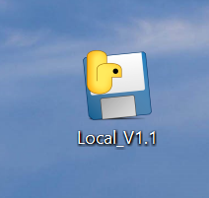

Figure 23:App used for uploading data

1. Click Select **File and Upload**

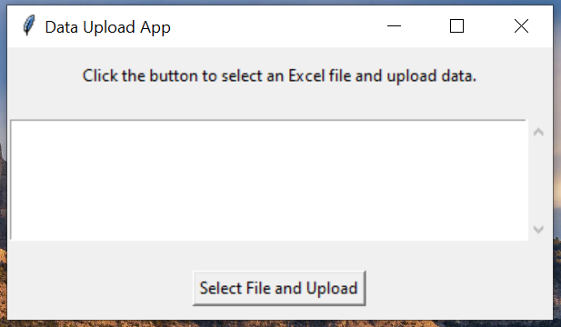

Figure 24:App display

Browse for the saved file and open.

1. Success message

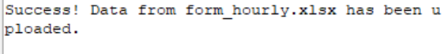

When the data are uploaded the success message is shown.

1. **DATA TRANSFER TO CENTRAL DATABASE**
2. **Data Push:** data are transferred to the central data base by using the feature of climsoft called **Push** available on each form.

**Note:** When push is clicked once, all data from that form are transferred.

1. **External app:** when this is used tada from form_houry and form_daily1 are transferred.

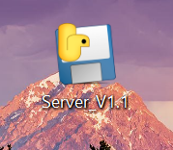

1. **Data export and send via email**

# **CONCLUSION**

This document provides an overview of the essential skills required for working with Climsoft. It covers installation and configuration, data entry, quality control, data transfer, archiving, and the generation of various data products. It also emphasizes the use of external tools that complement Climsoft in performing data quality control and managing data inventories, as well as supporting data entry processes. By following this manual, trained users are expected to be able to install and configure Climsoft, carry out all related tasks, and effectively apply the external tools for both data entry and quality control.